Sports medicine physical examination
(Version: 01.02.2023)

Examination date:
Clinician:
Name, first name:
Date of birth:
Gender: | male female

NL significant finding

- Head/neck

Eyes Glasses Contact lenses
Visual acuity (distance visual acuity) left uncorrected right uncorrected
left corrected right corrected
Nose/sinuses
Teeth
Throat/Tonsils
Ears/eardrum
Thyroid gland
other

- Thorax/lungs

Auscultation
Percussion
Rib cage
other

- Heart/Circulation

Pulse: /min Blood pressure: / mmHg
Auscultation
Heart sounds

Peripheral pulses
Veins

NL significant finding

- Lymph nodes cervical r/l axillary r/l
inguinal r/l other

5. Skin

- Abdomen
Palpation
Liver
Spleen
Kidney lodges
Hernias/Genitals/Tanner stage.

- Nervous system
Reflexes ASR r/l PSR r/l other
Sensitivity
Muscle function

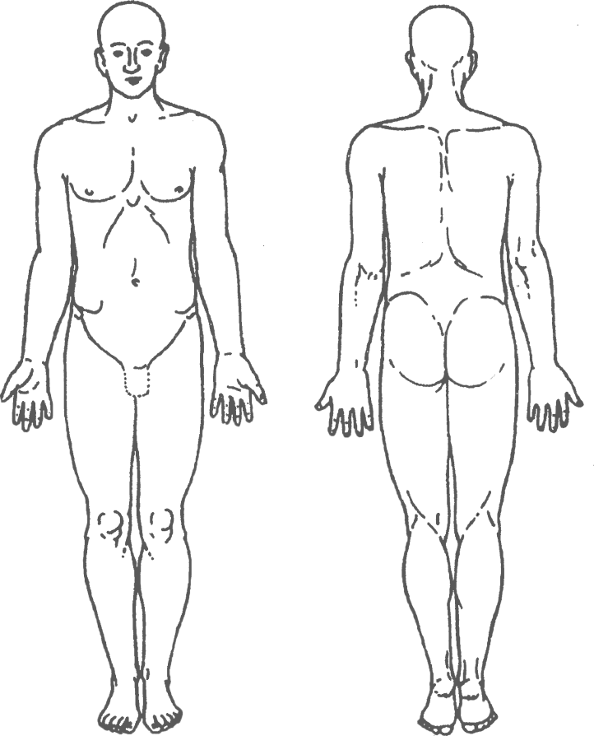
Mark pathological findings (for sections 1 – 7):
NL significant finding

- Musculoskeletal system
Gait/posture/limb alignment
Spine curvature
Pelvis tilt towards right left minus cm
Sacroiliac joint
Leg length
Cervical spine
Thoracic spine
Lumbar spine
Shoulder girdle
Elbow
Hand/wrist
Hip
Knee
Ankle joint
Foot
Muscle lengths/flexibility
Functional tests
Sport-specific findings
Comments

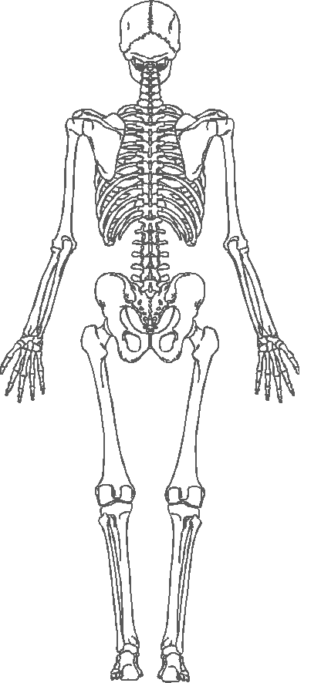
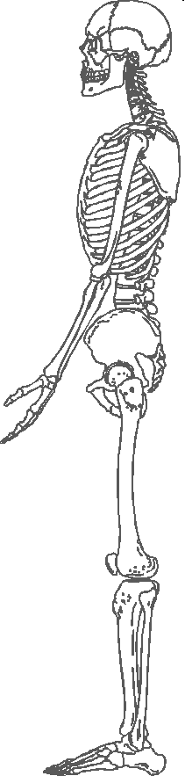
Mark pathological findings (for section 8):

